**Question-1:-** 1. Create a simple shell script to tell the user about their session – they need to know:

● What their username is

● What the current date is

● What the time is

● What their current working directory is

● How many files they have in that directory

● What is the biggest file in their current directory

Ans:-

Script**:- #! /bin/bash/ -x**

**echo "Your Username is:"$USERNAME**

**echo "Current Date:"**

**date -u +%D**

**echo "Current Time:"**

**date -u +%T**

**echo "Current Working Directory is:"$PWD**

**echo**

**echo "Total Files Present in this directory:"`ls | wc -l`**

**echo**

**echo "Biggest File in Current Directory is:"`sudo du -a /$PWD/ | sort -n -r | head -n 1 | awk '{print $2}'`**

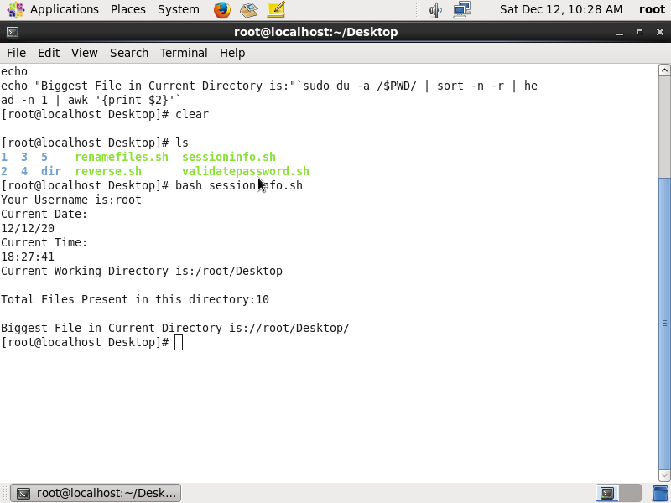

fig shows users session information

**Question-2:-** Create a directory with a few test files in it (the files can be empty). Now write a script that for every file in that directory you rename it to have an extension of today's date in YYYYMMDD format.

Ans:-

Script:-

**#! /bin/bash -x**

**cd dir**

**for fileName in `dir`;**

**do**

**mv $fileName $fileName`date -u +%Y%m%d`**

**done**

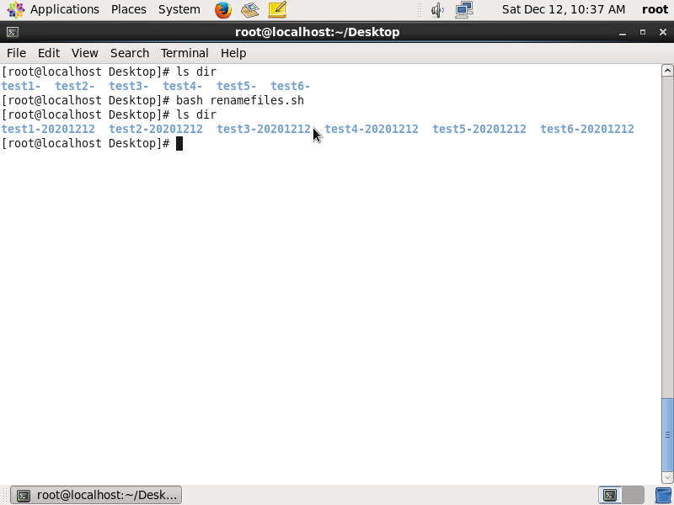

Fig shows renaming files with todays date as extension

**Question-3:-** Write a script that takes a number as an input and reverses it out to the user. For example, if the original number is 74985, the output should be 58947.

Ans:-

Script:-

**#! /bin/bash -x**

**read -p "Enter a number to reverse:" number;**

**temp=$number;**

**r=0;**

**rev=0;**

**while [ $temp -gt 0 ];**

**do**

**r=$temp%10;**

**rev=$(((($rev)*10)+$r));**

**temp=$(($temp/10));**

**done**

**echo "Given Number is:"$number;**

**echo "Reversed number is:"$rev;**

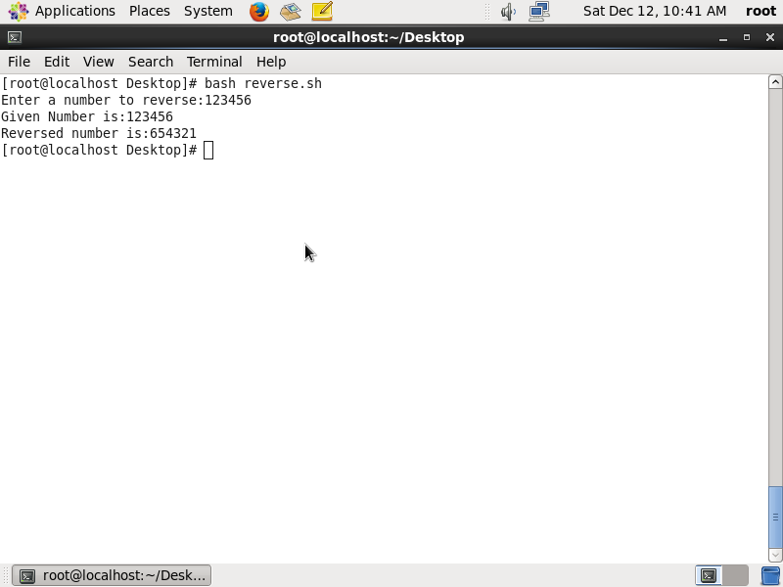

Fig shows reversing a given number

**Question-4:-** Write a script to validate how secure someone's password is. Things you would care about:

● Length should be 8 or more characters

● The password should contain numbers and letters

● There should be both uppercase and lowercase letters

Ans:-

Script:-

**#! /bin/bash -x**

**read -p "Enter password to validate: " password;**

**len="${#password}";**

**if test $len -ge 8; then**

**echo "$password" | grep -q "[0-9]"**

**if test $? -eq 0; then**

**echo "$password" | grep -q "[A-Z]"**

**if test $? -eq 0; then**

**echo "$password" | grep -q "[a-z]"**

**if test $? -eq 0; then**

**echo "Strong Password"**

**else**

**echo "Password should contain atleast one LOWER case letter"**

**fi**

**else**

**echo "Password should cointain atleast one UPPER letter"**

**fi**

**else**

**echo "Password should contain atleast one digit"**

**fi**

**else**

**echo "Password should contain atleast 8 characters"**

**fi**

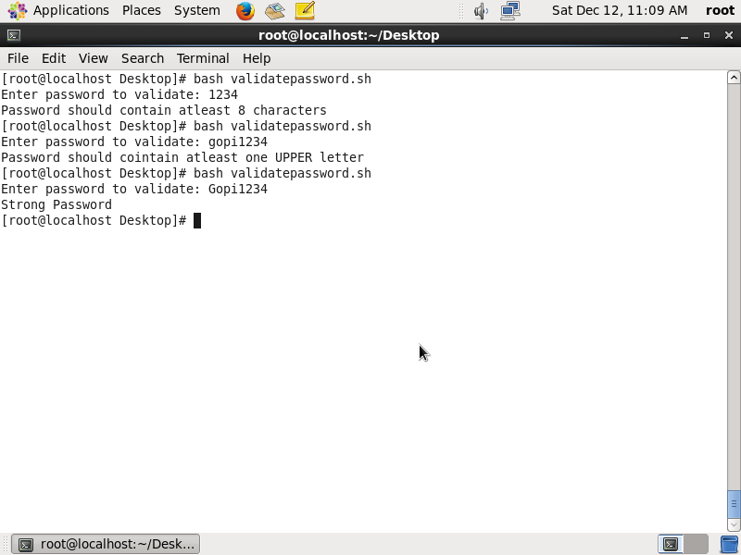

Fig shows how secure someone’s password is.